9th Annual CAMDEN DAFFODIL FESTIVAL SHOW & SHINE
COLLECTOR/SPECIAL INTEREST VEHICLES & MOTORCYCLES
Saturday, March 14, 2020
Register from 9am until 11:00 a.m.
Location the corner of Haynes & Washington Streets
Trophies awarded @ 2:30 p.m.
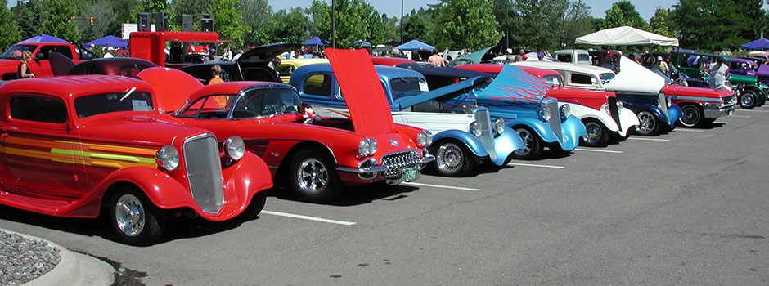
Show entry $15.00 per owner, additional vehicles $5.00 each
Vehicles entered eligible for “Best of Show”
“1st & 2nd place awards for Best Pre-80 Model, Post 80 Model Cars,”
“Best Truck, Best Motorcycle, Corvette & Work in Progress”
Each paying entrant will receive a Free Shirt.
Rain or Shine
__________________________________________________________________________________________
Entry Form: Please fill out additional forms per entry

Name:_________________ City: ______ State:____ Email:_____________________________

Please check one: Pre 80’s ________ 81 & Later Models _______ Vehicle make: _________

Year: ______ Model: _______ Amount Due: ___________ Paid: Cash or Check

Liability Release: I agree not to hold any organizer, contributor or property owner associated with this event responsible for loss to myself or property by participating in this event. I also agree that any picture taken of my entry may be used for future advertising without any compensation to me.
Signature: ____________________________________________________________Date_________________
Sponsored by the Camden Daffodil Festival
For Additional Information contact
John Coons @ 870-833-0508 or k.coons@att.net or Chris Cross 870-807-4174

